Project Design Phase-II
Data Flow Diagram & User Stories

Date | JUNE 2026
Team ID
Project Name | Visualization Tool for Electric Vehicle Charge and Range Analysis
Maximum Marks | 4 Marks

Data Flow Diagrams:
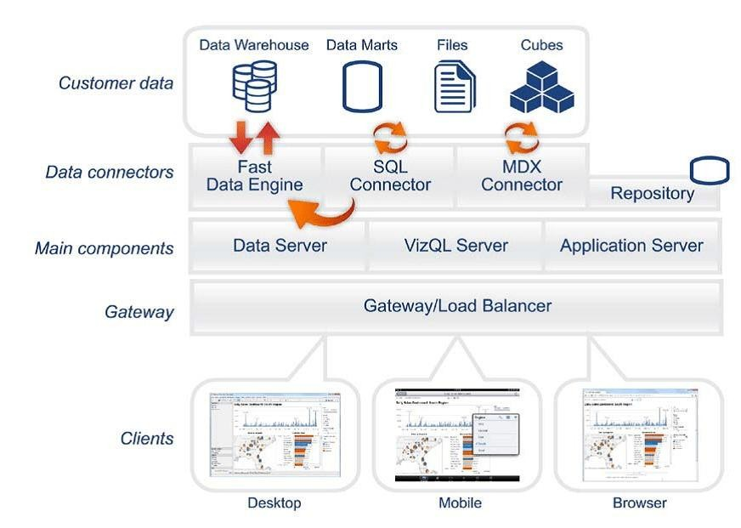
User Stories.
User Type | Functional  Requirement  (Epic) | User Story  Number | User Story / Task | Acceptance criteria | Priority | Release
Customer (Web user) | Dashboard Navigation | USN-1 | As a user, I can move from one dashboard to another using navigation buttons. | I can switch between dashboards easily | High | Sprint-1
Customer (Web user) | EV Data  Visualization | USN-2 | As a user, I can view EV charging stations state-wise in a bar chart. | Chart displays all states and charging station counts | High | Sprint-1
Customer (Web user) | EV Data  Visualization | USN-3 | As a user, I can analyze EV vehicle ranges and types in visual form. | Graphs show range differences among vehicles | Medium | Sprint-2
Customer (Web user) | Data Filtering | USN-4 | As a user, I can filter data based on state, city, or charger type. | Dashboards respond to  filter selections | High | Sprint-2
Customer (Web user) | Tooltip  Interactions | USN-5 | As a user, I can hover over a chart to get more detailed information. | Tooltip values appear correctly | Medium | Sprint-2
Administrator | Dataset  Management | USN-6 | As an admin, I can upload and preprocess datasets using Python scripts. | Cleaned datasets are  generated and saved locally | High | Sprint-1
Administrator | Dashboard Deployment | USN-7 | As an admin, I can publish dashboards to Tableau Public. | Dashboards are publicly accessible through a link | High | Sprint-1

